BURRILLVILLE POLICE
DEPARTMENT
1477 Victory Highway PO Box 231
Burrillville, Rhode Island 02830 401-568-6255
CITIZENS POLICE ACADEMY REGISTRATION FORM

PURPOSE: To provide the citizens of Burrillville an opportunity to learn about the Burrillville Police Department, its police officers, the department mission and tasks performed by officers of the Department.
TOPICS WILL INCLUDE:

The history and structure of the department, community policing, radio, communications and the 911 system, search and seizure, the elements of crimes and laws of arrests, patrol procedures, use of force, accident and crime scene investigations, detective, BCI, SRT and juvenile divisions, traffic stops, RADAR, firearms, elderly affairs, domestic violence and DUI investigations.
Name Address City

State

Phone
Zip

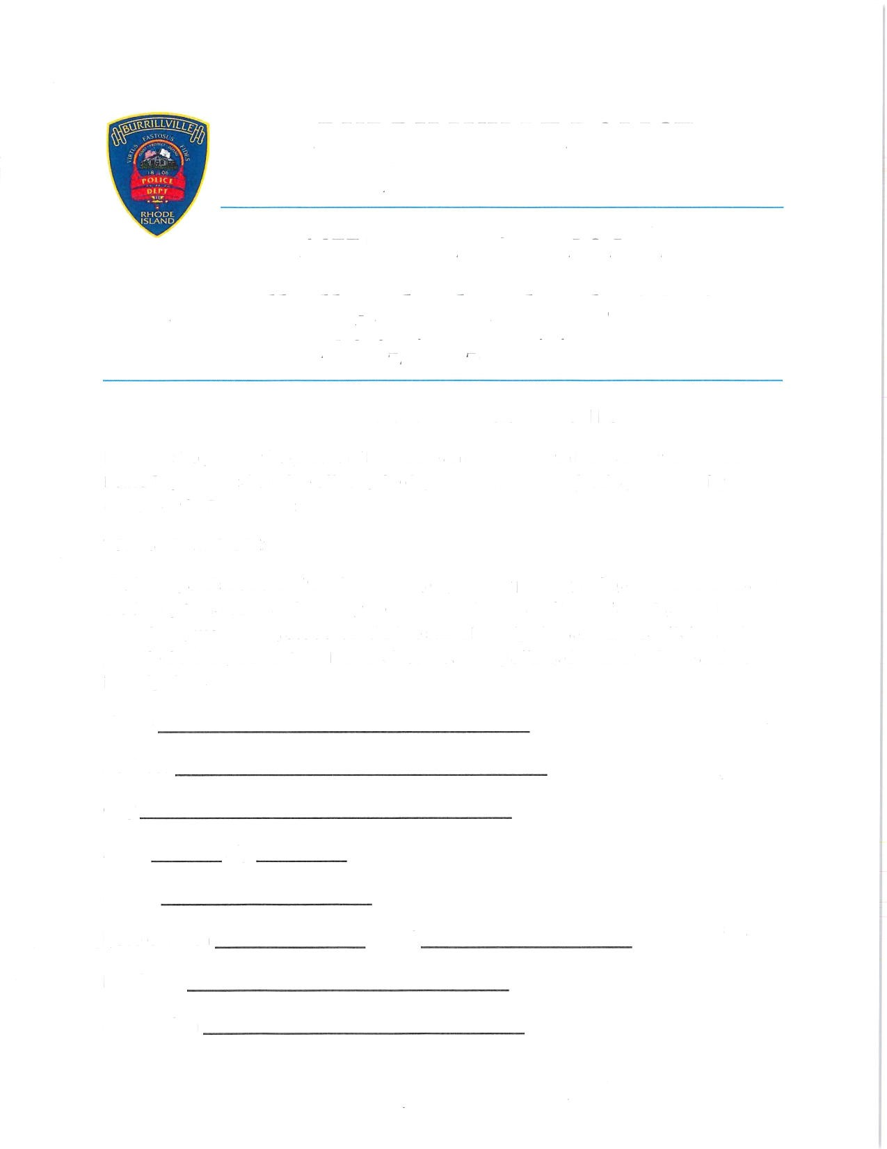
Date of Birth Email

Employer

Occupation

I understand that the Burrillville Police Citizens Police Academy will meet for a total of twelve weeks and participants who attend eighty percent of the sessions will receive a certificate of completion. A ride along with a Burrillville Police Officer will be included in the curriculum. All applicants will be subject to a criminal background check.

[ agree to these conditions.

Polo shirt size (circle one) Small Medium Large X-Large 2X 3X

Signature Date

Mail the above completed application to:

Burrillville Police Department

Citizens Police Academy

1477 Victory Highway PO Box 231

Burrillville, Rhode Island 02830
All applicants will be informed of their of their application status.
For further information call Lieutenant William Lacey or Det. Robert Veader.
Must be 17 years old attend the Burrillville Police Citizens Police Academy.

401-568-6255

