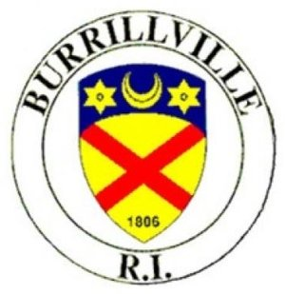
Phone (401) 568-4300 ext. 130
Fax (401) 710-9307
RI Relay 1-800-745-5555

Burrillville Planning Board
Special Meeting - Site Visit:
Pole 33 Log Rd, Harrisville, RI 02830
July 20, 2020
6:00 P.M.

Notice is hereby given that the Burrillville Planning Board will meet on Monday July 20, 2020 at 6:00 p.m. at Pole 33(entrance to gravel bank) Log Road, Harrisville, RI 02830 for a site visit regarding:

Log Road Solar, Pole 33 Log Road, AP 237, Lot 5:
Pre-Application Review, Major Land Development: acre 4.997 MW ground mounted solar energy system. https://www.burrillville.org/sites/burrillvilleri/files/uploads/econox_renewables_log_road_pre_appliction_plans_5-20-20.pdf

The purpose of this meeting is to view the site for this proposed land development project.

Leo Felice, Vice Chairman
Burrillville Planning Board

